Week 4, Lab A – File Handling

# Lab Intro & Prep

* Create a new Java Project in Eclipse named **Week 4**
* Download the sample text files (**sample1.txt** and **temps.dat**) from Moodle
* Place the sample text files in the **Week 4 Project directory** (**do not place them in the src folder)**

## Learning Objectives

* Using Java file handling classes to read and write text files.
* Interpreting mixed formatted data using the **Scanner** class.

# Exercise 1 – WordCount

Create a class named **WordCount** that takes the name of a text file as a command-line argument and outputs the number and average length of words in the file to the console. You can treat ‘words’ as any text separated by whitespace – i.e. treat the output of **Scanner.next()** as a ‘word’. The program should give appropriate errors if there is no file specified on the command line, or the file cannot be opened. Test it with **sample1.txt**. The correct output can be seen in Fig 1.

Set the command line argument in Eclipse using the **Run Configurations** dialog (see Fig 2 & Fig 3). Open the ‘Arguments’ tab and set the arguments there.

**Hints**:

* The length of a string can be obtained via **stringName**.**length()–** this returns an integer corresponding to the length of the string
* To calculate the average length of the words, you need to keep track of the total number of words

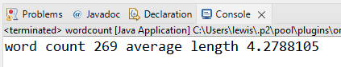

Fig 1 – Word count and the average length of words in sample1.txt

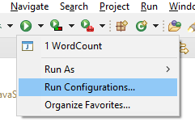

Fig 2 – Run Configurations

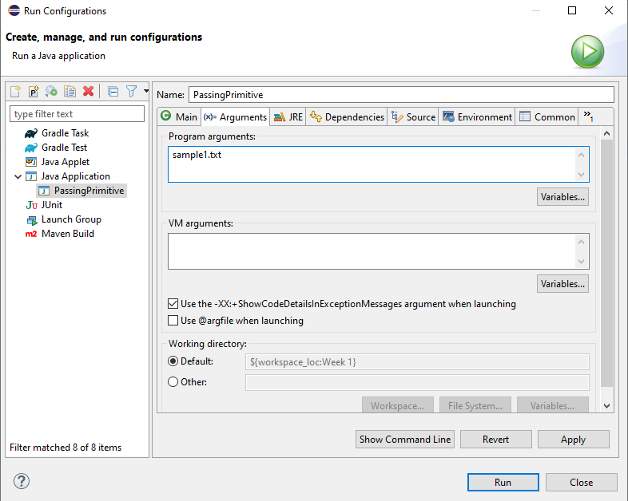

Fig 3 – Run Configurations Window

# Exercise 2 – Temperature

The file **temps.dat** contains some temperature monitoring data. The file contains dates, times and temperature readings from two sensors in Celsius. Look at the file to figure out the format (you can open it in **Notepad++** or view it in Eclipse by double-clicking the file), then write a console program that reads this data and writes out the minimum and maximum temperatures recorded by each of the two sensors (Fig 4).

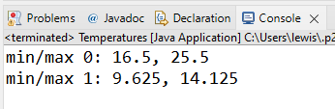

Fig 4 – Exercise 2 Example Output

# Extension Exercise – Temperature Statistics

Extend your solution to Exercise2 to write out some extra statistics – the mean temperatures and the time and date for each maximum and minimum. Then add file output: the two columns of temperatures could be output as a **comma-separated values** file which could be read into Excel.